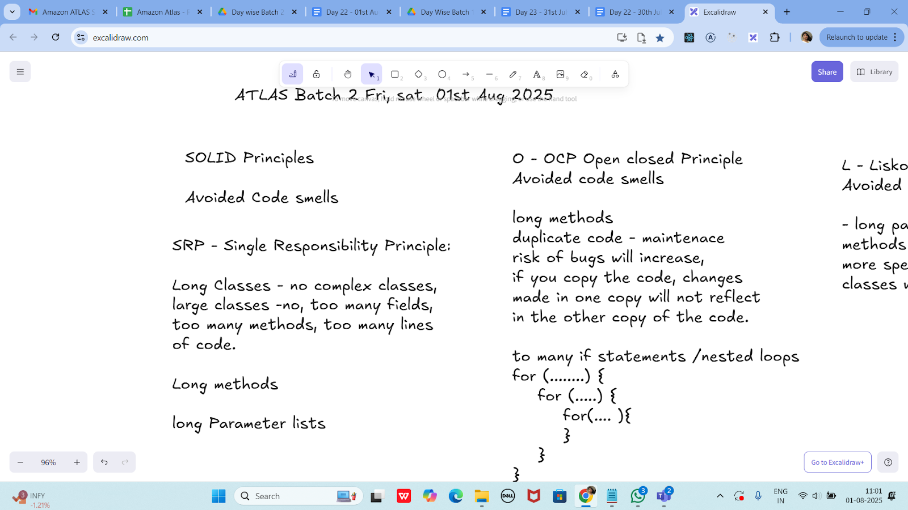

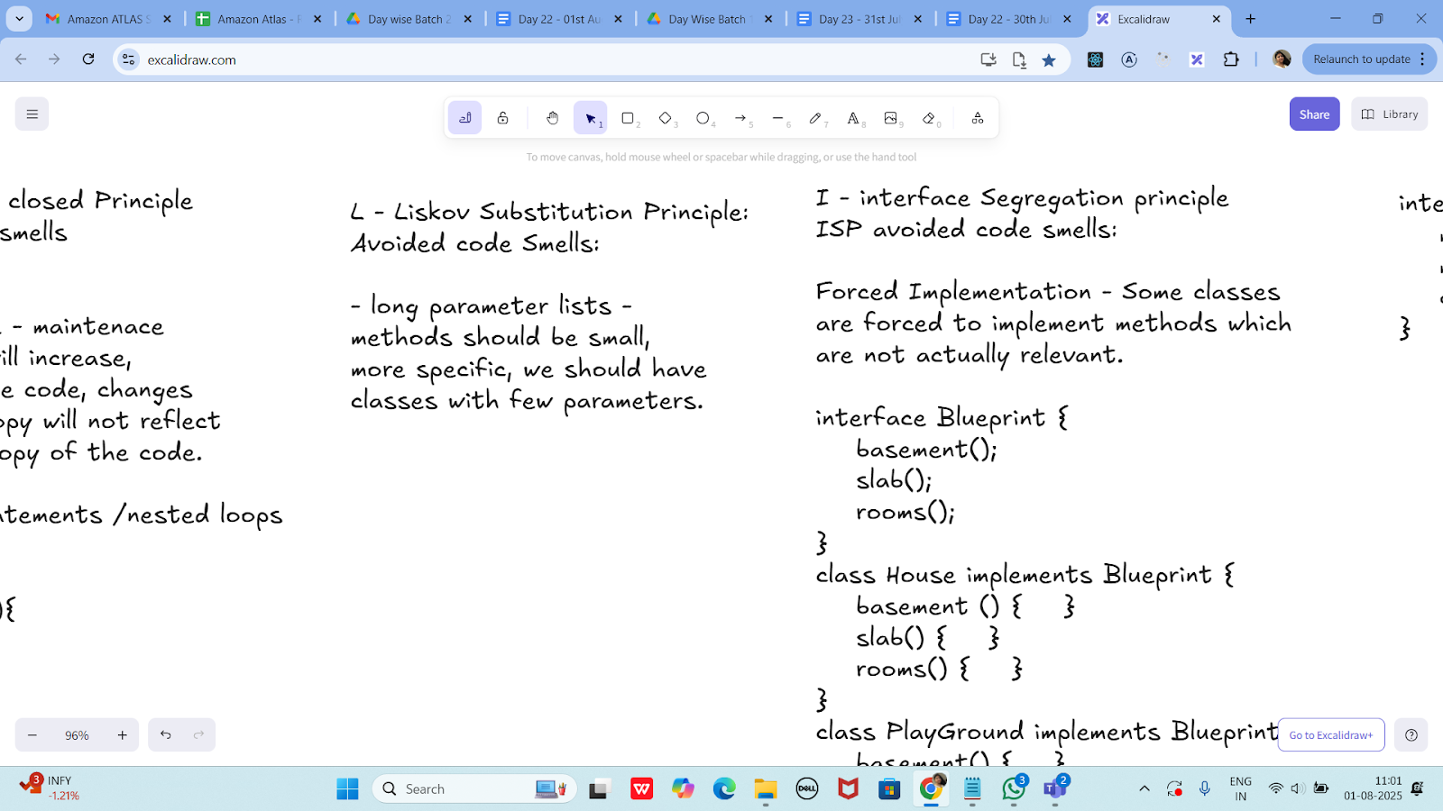

I - interface Segregation principle
ISP avoided code smells:

Forced Implementation - Some classes
are forced to implement methods which
are not actually relevant.

interface Blueprint {
basement();
slab();
rooms();
}
class House implements Blueprint {
basement () { }
slab() { }
rooms() { }
}
class PlayGround implements Blueprint {
basement() { }
slab() {...nothing to da} //?
rooms() {nothing to do } // ?
}

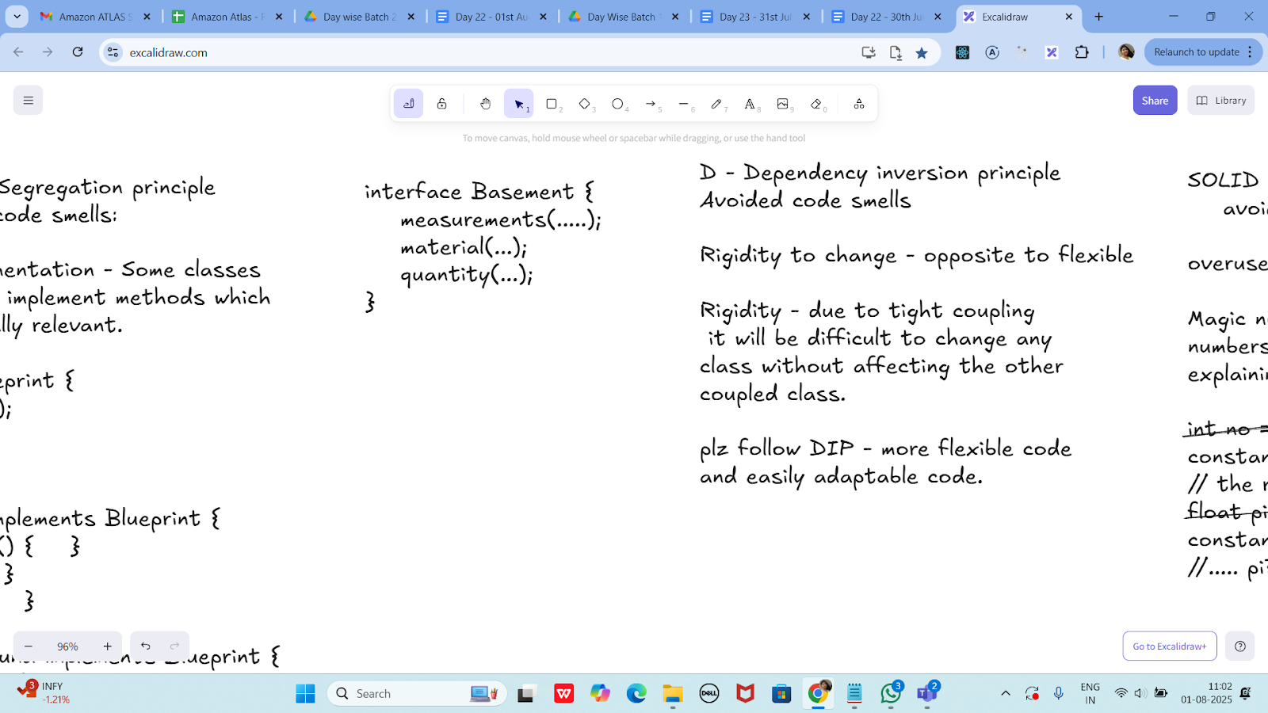

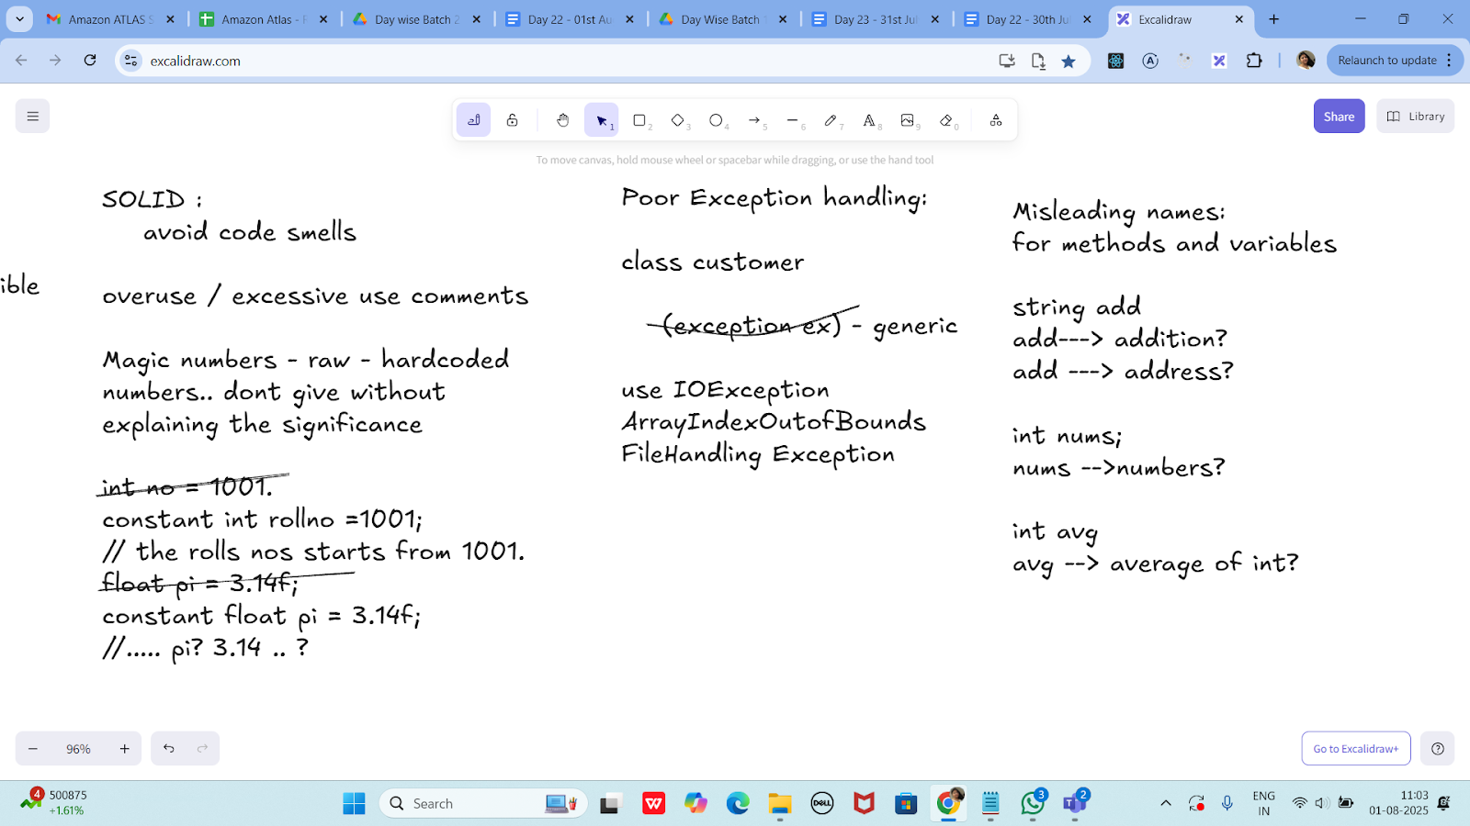

Task 1:

What do you mean by GOOD Code and BAD CODE?

Feature | Good Code | Bad Code
Readability | Clear and easy to follow | Confusing or messy
Naming | Meaningful names | Short or vague names
Structure | Well-organized, modular | Disorganized or duplicated
Maintenance | Easy to fix or update | Hard to change without breaking things
Standards | Follows Java conventions | Ignores conventions
Documentation | Well-commented where needed | No or excessive useless comments

Example of GOOD Java code:

public class Calculator {
public int add(int a, int b) {
return a + b;
}

public int multiply(int a, int b) {
return a * b;
}
}

Example of BAD Java code:

public class C {
int a(int x, int y) {
int z = 0;
z = x + y;
return z;
}
}

Task 2:
What do you understand by databinding?
Data binding is a programming technique that connects the UI (User Interface) with the data source so that changes in one automatically reflect in the other.

Why Use Data Binding?
- Reduces boilerplate code.
- Improves readability and maintainability.
- Keeps UI in sync with data automatically.
Task 3:

What do you know about continuous development?

Continuous Development is a broad software development approach that emphasizes frequent, automated updates to code, moving changes smoothly through development, testing, and deployment. It involves multiple integrated practices to ensure faster, more reliable software delivery.

Term | Description
Continuous Integration (CI) | Automatically building and testing code whenever developers push changes to a shared repository.
Continuous Delivery (CD) | Automatically preparing code for release to production after passing all tests.
Continuous Deployment | Automatically deploying every change that passes tests directly to production.
Continuous Testing | Automated tests run as part of the pipeline to catch bugs early.

Task 4:

What are the conditions for polymorphism?

Condition | Required for
Inheritance / Interface usage | Both types
Method Overriding | Runtime polymorphism
Method Overloading | Compile-time polymorphism
Upcasting to parent class | Runtime polymorphism
Same method signature (override) | Runtime only
Different parameter list (overload) | Compile-time only

1. Inheritance or Interface Implementation
- Polymorphism only works when a class extends another class or implements an interface.
class Animal {
void speak() {
System.out.println("Animal speaks");
}
}
class Dog extends Animal {
void speak() {
System.out.println("Dog barks");
}
}

2. Method Overriding (for Runtime Polymorphism)
- The subclass must override a method from the parent class.
- Method signatures (name and parameters) must match exactly.
- The method in the parent class should not be final, private, or static.

3. Upcasting
- A parent class reference must be used to refer to a child class object.
Animal a = new Dog(); // Upcasting
a.speak(); // Calls Dog's version of speak() at runtime

4. Method Overloading (for Compile-time Polymorphism)
- Same method name with different parameter lists (number or type).
class Calculator {
int add(int a, int b) { return a + b; }
double add(double a, double b) { return a + b; }
}

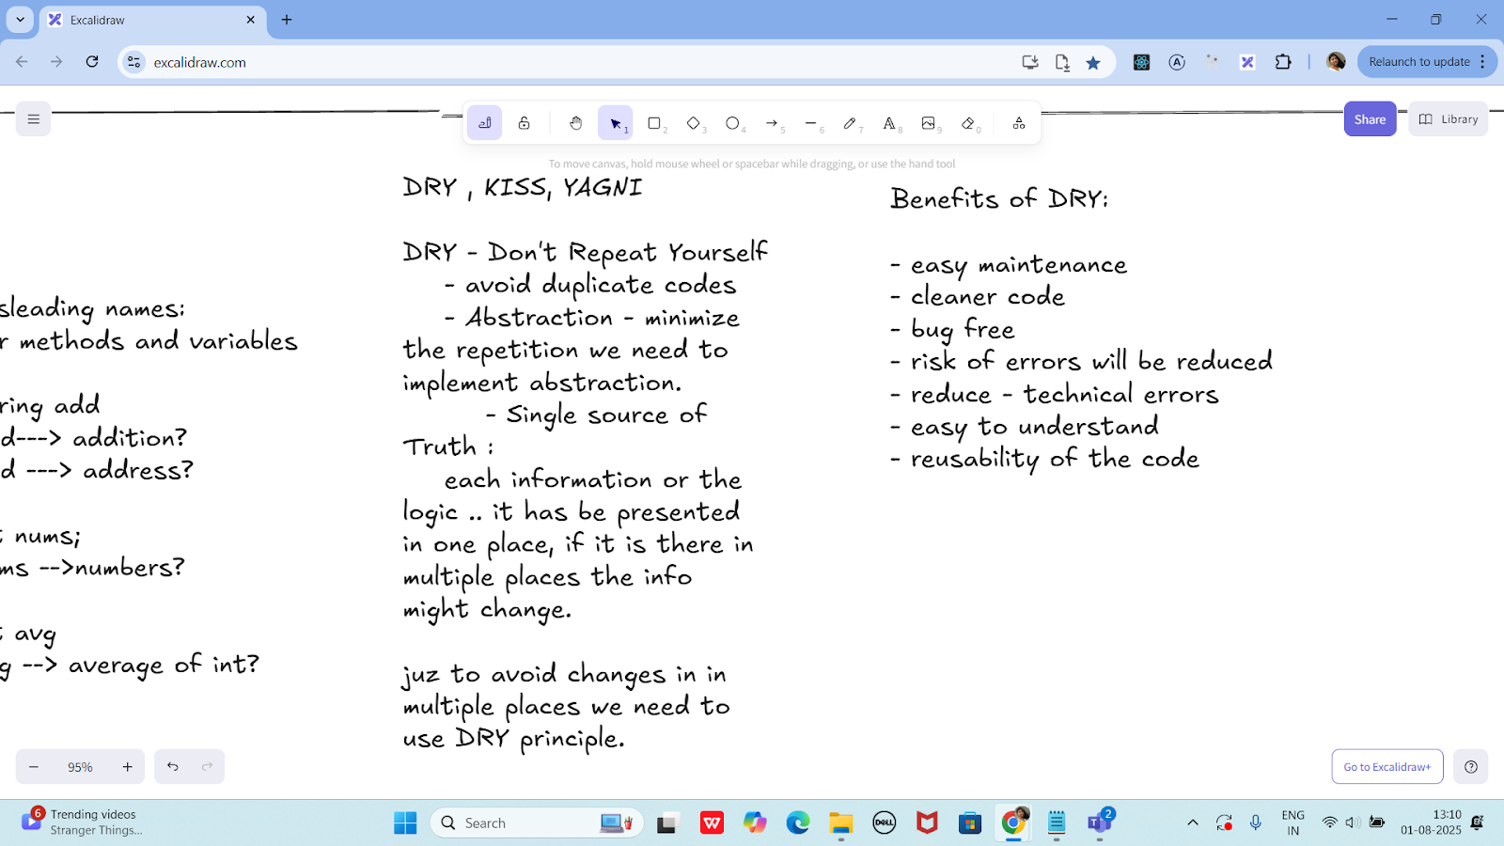

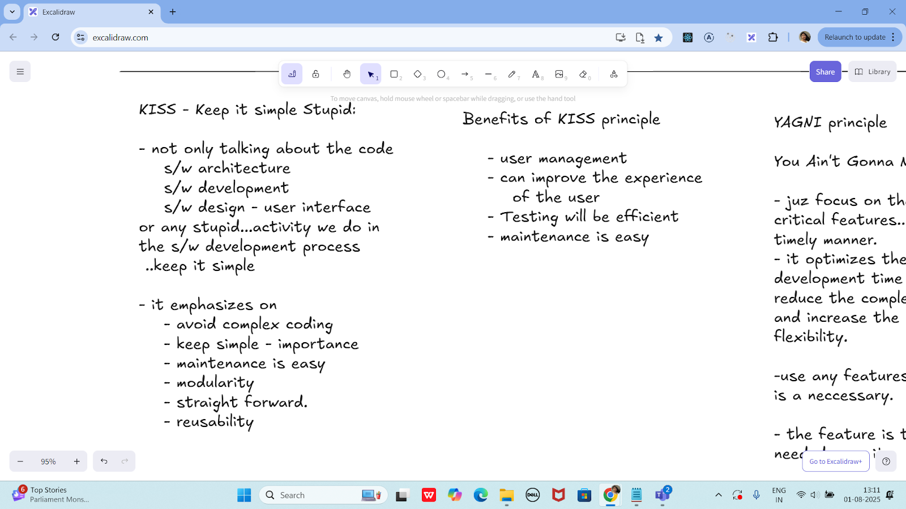

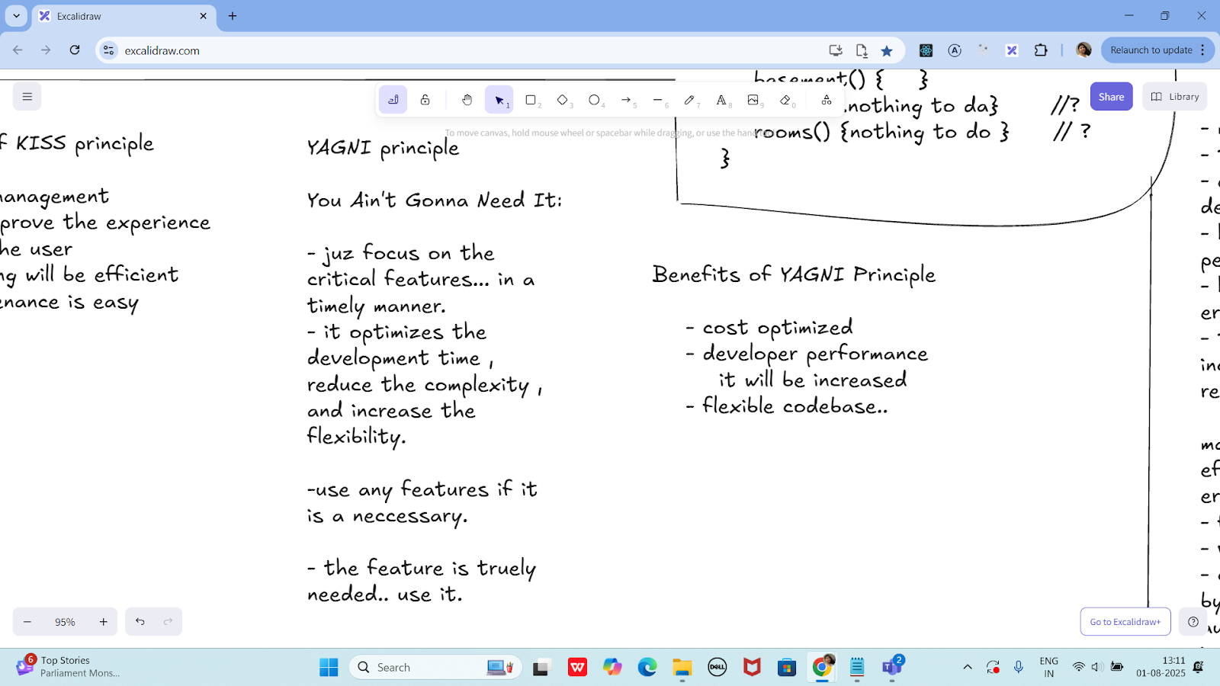

Task 05:
What is, why is it used , where is it used..
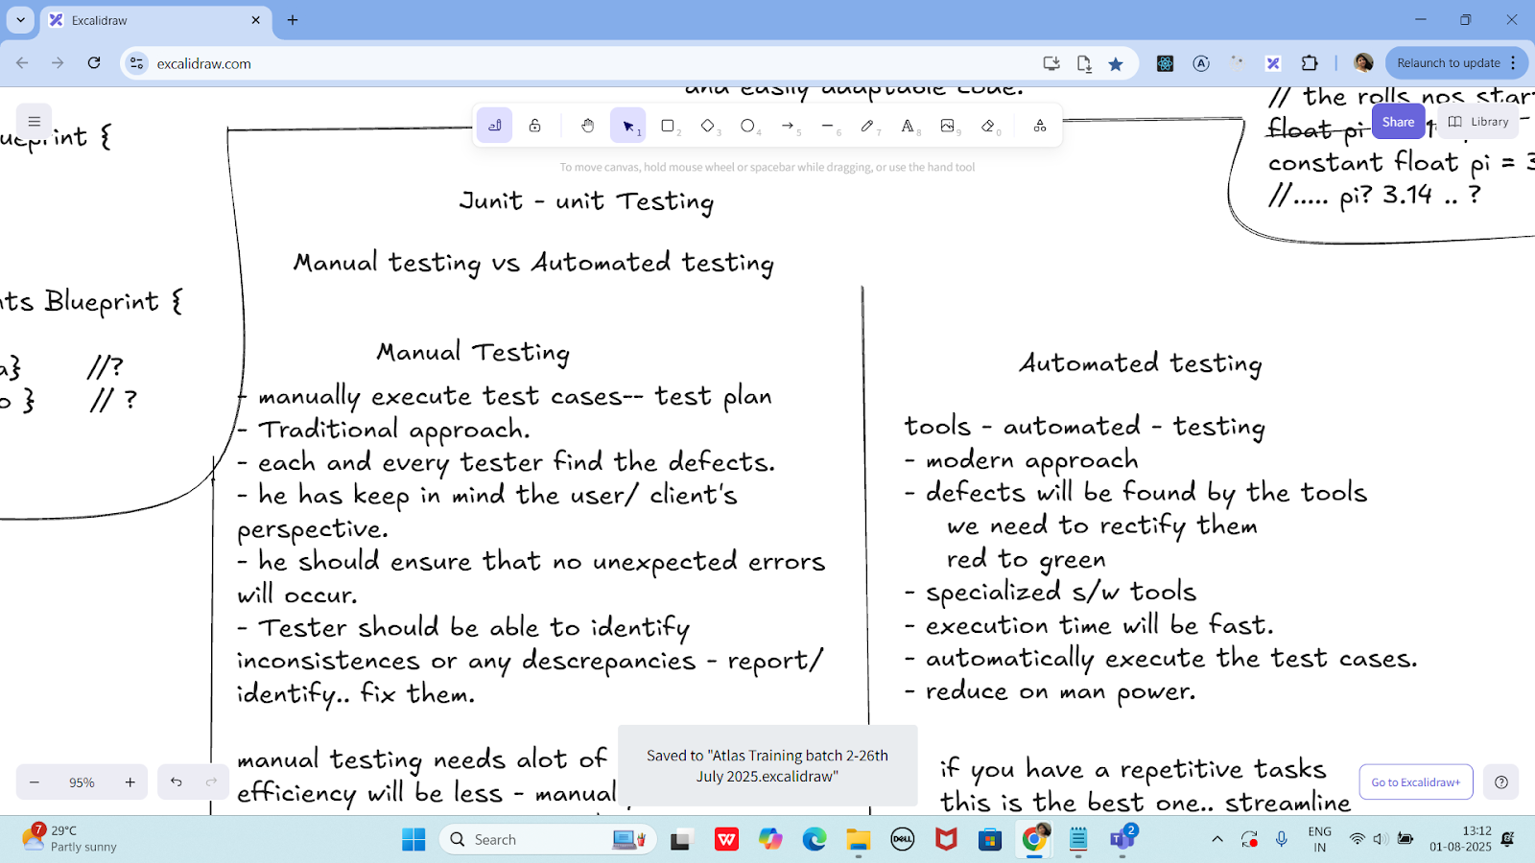

TDD and BDD approach..

TDD (Test-Driven Development) is a software development approach where you write tests before writing actual code. The process is based on short development cycles:

TDD Cycle (Red-Green-Refactor):
- Write a failing test (Red)
- Write just enough code to pass the test (Green)
- Refactor the code to improve structure, while keeping the test passing

Why TDD is Used:
- Ensures code meets requirements
- Reduces bugs early
- Encourages modular, testable code
- Improves code design and maintainability

Where TDD is Used:
- In unit testing frameworks like JUnit (Java), NUnit (C#), PyTest (Python)
- Common in Agile and Extreme Programming (XP)
- Used in backend services, libraries, APIs, and core business logic
BDD – Behavior-Driven Development
BDD (Behavior-Driven Development) is an extension of TDD that focuses on the behavior of the application from the user’s perspective.
BDD uses natural language (like English) to describe how the system should behave, often in a format like:
Given – When – Then

Why BDD is Used:
- Improves communication between developers, testers, and non-technical stakeholders
- Encourages collaboration
- Makes tests more understandable (even for non-developers)
- Focuses on user behavior, not just code correctness

Where BDD is Used:
- In tools like Cucumber, JBehave (Java), SpecFlow (.NET), or Behave (Python)
- Used in UI testing, end-to-end testing, acceptance tests
- Ideal for cross-functional Agile teams

Term | Meaning | Why It's Used | Where It's Used
TDD | Write tests first, then code | Prevent bugs, better design | Unit testing, core logic
BDD | Describe behavior in plain language | Better collaboration, user-focused testing | Acceptance testing, UI testing



- manually execute test cases-- test plan
- Traditional approach.
- each and every tester find the defects.
- he has keep in mind the user/ client's
perspective.
- he should ensure that no unexpected errors will occur.
- Tester should be able to identify inconsistences or any descrepancies - report/ identify.. fix them.

manual testing needs alot of Manpower.
efficiency will be less - manually.
errors are prone to occur - human typos
- feedback - manually
- version changes - track of
- cost - effective - can cut on cost..
by not implementing any s/w's, automation tools.. need not have to invest on that
- human resources -10 employees -
pay the salary..

Automated testing

tools - automated - testing
- modern approach
- defects will be found by the tools
we need to rectify them
red to green
- specialized s/w tools
- execution time will be fast.
- automatically execute the test cases.
- reduce on man power.

if you have a repetitive tasks
this is the best one.. streamline
it will improve the test coverage
faster development compared to
manual test.

Task 06:

List down the Manual and automated testing tools

Common Manual Testing Tools:

Tool Name | Purpose
TestRail | Test case management, tracking test plans and runs
PractiTest | Test management and QA visibility
Xray | Jira plugin for test management
Zephyr | Test management tool integrated with Jira
qTest | Test case management and analytics
TestLink | Open-source test case management
Bugzilla | Bug tracking tool
Jira | Issue tracking and test case management (with plugins)
HP ALM / QC | Enterprise-level test management tool
MantisBT | Simple bug and issue tracking tool

Common Automated Testing Tools::

Tool Name | Type | Purpose
Selenium | UI/Web | Automate web browsers (Java, Python, etc.)
JUnit | Unit | Java unit testing
TestNG | Unit/Integration | Advanced testing in Java
Appium | Mobile | Test mobile apps (Android/iOS)
Cypress | Web | End-to-end testing for web apps
Postman | API | Manual + automated API testing
Rest Assured | API | Automated REST API testing in Java
SoapUI | API | SOAP/REST API functional and load testing
Cucumber | BDD | Behavior-Driven Testing with Gherkin syntax
JMeter | Performance | Load testing and performance analysis
Playwright | Web | Modern browser automation (cross-browser)
Robot Framework | Generic | Keyword-driven automation (Python-based)
Katalon Studio | All-in-one | Web, API, mobile, and desktop automation
Ranorex | GUI | Desktop, web, and mobile app testing
HP UFT (QTP) | Functional | Enterprise test automation

Junit

setup - environmental

JDk 1.5 or above

is java installed in your system

JAVA_HOME = "...path "
c:\programfiles\Java\jdk...

download JUnit archive
junit.org/junit5/

- .jar file ==> junit4.11.jar

set environmental variables
JUNIT_HOME = "Path.."
c:\programfile\junit

classpath ==> junit jar
..... \junit4.11.jar

In intellij — check for extensions — and plugin (install junit from the extensions of intellij ide)
Same for vscode users also

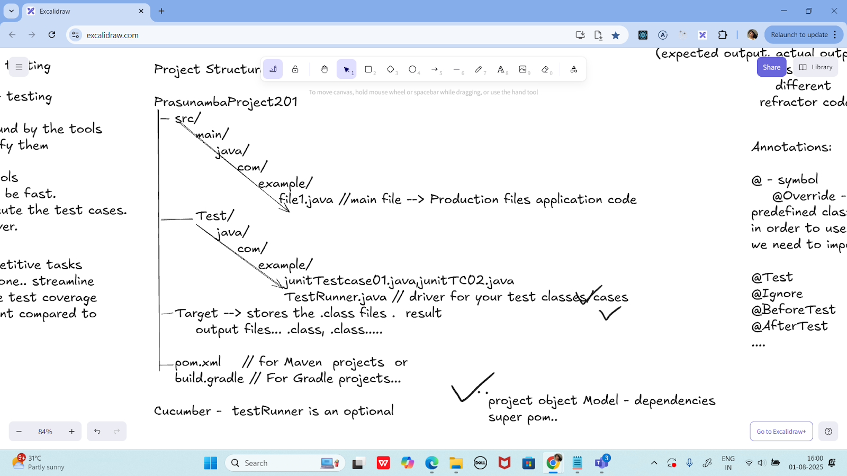

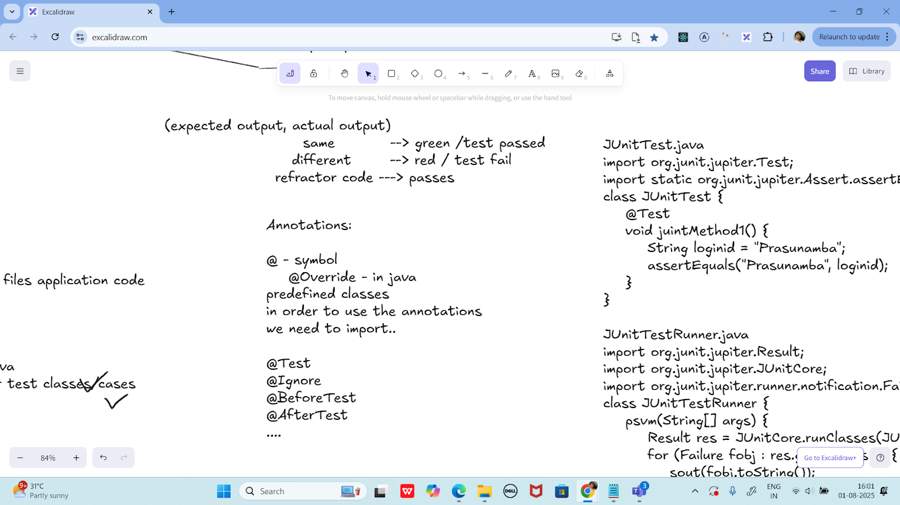

JUnitTest.java
import org.junit.jupiter.Test;
import static org.junit.jupiter.Assert.assertEquals;
class JUnitTest {
@Test
void juintMethod1() {
String loginid = "Prasunamba";
assertEquals("Prasunamba", loginid);
}
}

JUnitTestRunner.java
import org.junit.jupiter.Result;
import org.junit.jupiter.JUnitCore;
import org.junit.jupiter.runner.notification.Failure;
class JUnitTestRunner {
psvm(String[] args) {
Result res = JUnitCore.runClasses(JUnitTest.class);
for (Failure fobj : res.getFailures()) {
sout(fobj.toString());
}
sout(res.wasSuccessful()); --true / false
}
}

cmd :
javac JUnitTest.java JUnitTestRunner.java
-- this above cmd will create .class files in Target folder.

java JUnitTestRunner

Features of JUnit Test Framework

--> Test runners
--> Test Suite
--> JUnit classes
--> Fixtures

Fixtures:

the fixed state of a set object.. used
as a baseline for running the test cases.

these objects are used the run the tests
baseline

setUp() - values x = 10, y 20;
this method runs before every testcase ...
tearDown()
this method runs after every testcase ...

5 test cases -- running

values x = 10, y 20;
Test 01 msg
values x = 10, y 20;
Test 02 msg
values x = 10, y 20;
Test 03 msg
values x = 10, y 20;
Test 04 msg
....

import org.junit.After;
import org.junit.Before;
import org.junit.Test;
import org.junit.runner.JUnitCore;
import org.junit.runner.Result;
import org.junit.runner.notification.Failure;
import static org.junit.Assert.assertEquals;
import static org.junit.Assert.assertNull;
public class JunitTestCase04 {
//setUp and tearDown demo
public class DemoClass {
String str;
@Before
public void setUp() { // initialization
System.out.println("setUp method called");
str = "initialise the setup";
}
@After
public void tearDown() { // deinitialization
System.out.println("tearDown method called");
str = null;
}
public String getStr() {
return str;
}
}
@Test
public void testStrinitialsetup() {
DemoClass obj = new DemoClass();
String res = obj.getStr();
assertEquals("initialise the setup", res);
}
@Test
public void testStrCleanUp() {
DemoClass obj = new DemoClass();
String res = obj.getStr();
assertNull(obj.getStr());
}
public static void main(String[] args) {
Result res = JUnitCore.runClasses(JunitTestCase04.class);
if(res.getFailureCount()> 0){
System.out.println("no of FAILURE cases are "+ res );
for(Failure failure : res.getFailures()) {
System.out.println(failure.toString()); // list of 10 failure cases..
}
}
else {
System.out.println("all PASS" );
}
}
}

================================================================================================================================================
Info Box

Plz refer Best Programming Practices - Doc 08 in Docs to study

Updated link at 12.17 ..

https://excalidraw.com/#json=lKmZDbhZ5V6ZRlQ3zJOXv,K6r0FziLUTf3htjdUrnN4w

Updated link at 15.57

https://excalidraw.com/#json=Mp0F2MJiO57HKm74LVHXK,XmhQybYlqAswiHdRIeokDQ

Junit dependency

https://junit.org/junit4/dependency-info.html

<dependencies >
<dependency>
<groupId>junit</groupId>
<artifactId>junit</artifactId>
<version>4.13.2</version>
</dependency>
</dependencies >

The above dependency you need to add in the dependencies tag of pom.xml..

Junit Official link

Download
Hamcrest and Junit.jar file

https://junit.org/

Or add the below dependency
<dependency>
<groupId>org.junit.jupiter</groupId>
<artifactId>junit-jupiter-api</artifactId>
<version>6.0.0-M2</version>
</dependency>

Hamcrest dependency

<!-- https://mvnrepository.com/artifact/org.hamcrest/hamcrest-junit -->
<dependency>
<groupId>org.hamcrest</groupId>
<artifactId>hamcrest-junit</artifactId>
<version>2.0.0.0</version>
<scope>test</scope>
</dependency>

================================================================================================================================================

